Scripture: 2 Kings 4:8-37
Memory Verse: Hebrews 13:6 “…. So, we say with confidence, “The Lord is my helper; I will not be afraid. What can mere mortals do to me?”
Color Elisha praying for the child
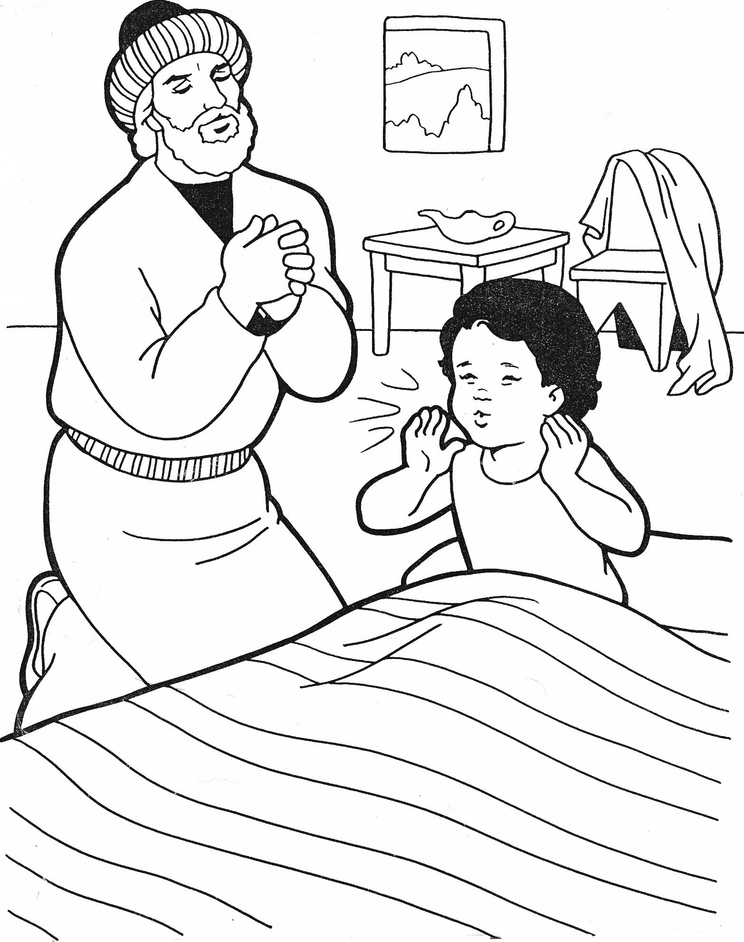
Today I learnt that I should trust God to bring out of bad situations!

